1. Definition of Violence Against Women and Children (VAWC) According to Philippine Laws
- Legal Definition:
According to Republic Act 9262 or the Anti-Violence Against Women and their Children Act of 2004, VAW is “any act or a series of acts committed by any person against a woman who is his wife, former wife, or against a woman with whom the person has or had a sexual or dating relationship, or with whom he has a common child, or against her child whether legitimate or illegitimate, with or without the family abode, which result in or is likely to result in physical, sexual, psychological harm or suffering, or economic abuse including threats of such acts, battery, assault, coercion, harassment or arbitrary deprivation of liberty.”

- Key Components:
- Physical Violence: Inflicting bodily harm.
- Sexual Violence: Coercion into sexual acts or exploitation.
- Psychological Violence: Emotional abuse, threats, or harassment.
- Economic Abuse: Deprivation of financial resources or access to support.

2. Proposed Solutions to Address VAWC Using ICT

Solution 1: Awareness and Education Campaigns
- Approach: Develop interactive and multilingual educational modules accessible via mobile and web platforms to educate citizens about VAWC laws, rights, and reporting mechanisms.
- ICT Role: Use gamified apps, videos, and infographics to spread awareness in local dialects (e.g., Chavacano).

Solution 2: Improved Reporting and Monitoring Systems
- Provide real-time tracking of case status to ensure timely intervention. Enable authorities to respond more effectively by streamlining communicatio. Include a feature for real-time live chat with counselors, advocates, or social workers, ensuring immediate help for those in danger.Provide location-based services, such as directing users to the nearest shelter, clinic, or police station.
- ICT Role: Add discreet emergency buttons in the app for instant notifications to trusted contacts or emergency responders.

Solution 3: Community-Based Surveillance and Reporting System
- Approach: Create a digital tool enabling community members to report suspicious activities or cases of abuse while maintaining confidentiality.
- ICT Role: Geolocation-enabled apps that alert nearby authorities or NGOs about incidents.

3. Conceptualized Mobile App: “SafeHaven”

App Overview
“SafeHaven” is a mobile application designed to empower individuals and communities to combat VAWC through education, reporting, and coordinated support services.

Key Features

1. Interactive Learning Portal
- Gamified lessons about VAWC laws and rights, tailored for all age groups.
- Multilingual support, like Chavacano, Tausug, Bisaya and etc.

2. Reporting and Assistance
- Chatbots for immediate support and referrals to nearby shelters, legal aid, or counselors.
- Emergency SOS button to alert authorities with GPS location.

3. Community Engagement Hub
- Crowdsourced reporting system for witnesses to report potential abuse.
- A map highlighting high-risk areas to aid local authorities in resource allocation.
- Rewards-based volunteer programs for spreading awareness or aiding in surveillance.

How It Solves the Problem
- Reduces stigma and fear of reporting through anonymity.
- Promotes proactive community involvement in addressing VAWC.
- Educates citizens, fostering a culture of zero tolerance toward abuse.

PISA Creative Thinking Framework Integration

- Generating Ideas: Brainstorm solutions focusing on local needs (e.g., language and cultural sensitivity).
- Evaluating and Improving Ideas: Assess feasibility, effectiveness, and inclusivity of proposed solutions through consultations with local stakeholders.
- Envisioning Improvements: Incorporate user feedback and new technologies (e.g., AI, machine learning) for better scalability and efficiency of the app.

---

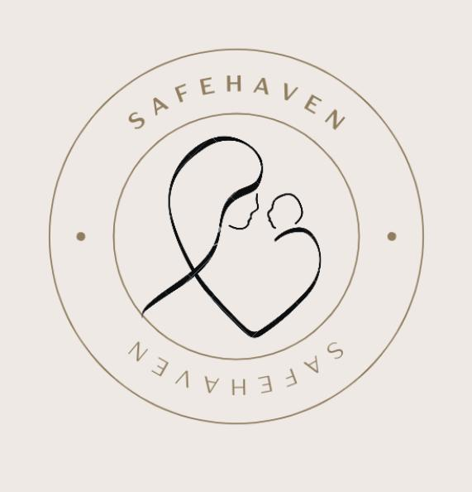

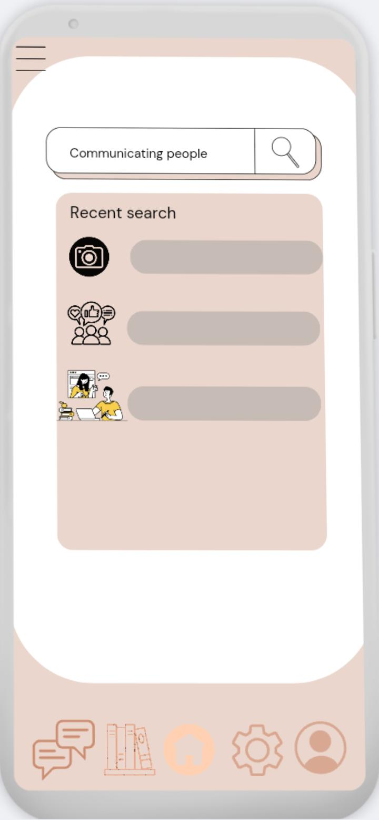
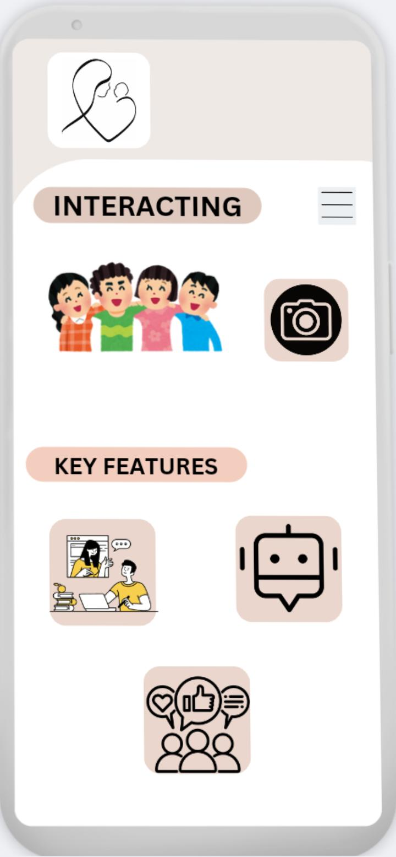
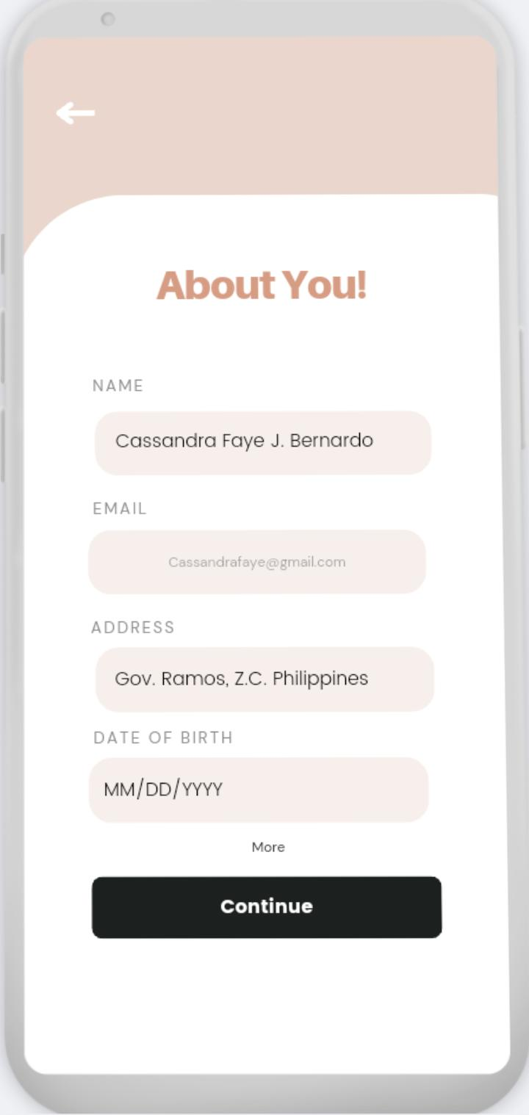
SAFEHAVEN
Logo

